- All pages:

Please follow this format for Title Bar

DD Icon
Module/Screen Name | Project Name


- All pages:

IN bottom of each page, show copyright thing as given in below example.
On Company Name give a hyperlink which will re-direct to Company website i.e. www.digidisruptors.com


- All pages:

All menus should be given a specific number and started with numeric like “200 : Manage Customer”
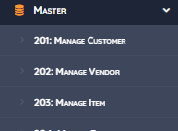

- Throughout the project:

Date Format should must be in dd-MMM-yyyy format. And if there is a time then simply use format dd-MMM-yyyy HH:mm
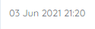

- All Summary Pages:
On bottom Pagination should be right alignment & Showing Entries should be left alignment, like shown in below example.

- All Summary Pages:

Grid should always show record count & that count should be in small square box like we have bedit, view box. It should be Kept on top right corner.

- Throughout the project and in summary screens:

Characters should be left aligned & all numeric should be right aligned.

- All Summary Pages:

Action Column and relevant buttons should always be in First Column.
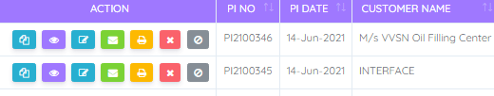

Color codes of buttons should be as of below…
View - purple i.e #9f78ff or #931ce3
Delete - soft red i.e #fa626b
Edit - strong Cyan i.e #28afd0
Mail - Green i.e #7bd235
Print - vivid orange i.e #fdb901
Add - Green i.e #7bd235. #2bcbba
Excel - Green i.e #7bd235. #2bcbba
Save - Green i.e #7bd235. #2bcbba
Search - Light Violet i.e #9f78ff.
Summary - i.e #2bcbba.

- All drop down / Combo boxes value should be in Ascending/Descending as required.

- In all print formats; Date, Page No. & Client details should be there as required.

- Login Authentication mechanism should be strengthened using below methods.

- SQL Injection in Login : On priority entire authentication routine should be reviewed to whitelist only valid characters. Any special characters that could be used to exploit SQL Injections or Cross Site Scripting attacks should be blocked.

- Password Change Without Verification : Old password verification and change of new password should not be done sequentially via client side JavaScript. Password change routine should do both verification of old and change to new in a single API request on server side.

- Password brute force (No account lockout) : An account lockout should be implemented for multiple invalid password attempts. Such a value could be set as per Project IT Security policy. Considering the functionality provided by the application such a value could be set to 5 at minimum.

- Password Hashing : It is highly recommended to implement an encoding mechanism to hash passwords before being submitted over Authentication API. In case hashing algorithm is used to store password on server side, the same may be utilized on client side to ensure passwords in plaintext are not subject to any sniffing or brute force attacks.

- Default test user ID : Default and test user accounts should not be part of any production environment. All user accounts as part of production setup should be validated for their purpose and approval before release.

- Provision to reset forgotten password : While there is a password change option available for logged-in user, there is no provision to reset forgotten password. Link provided for ‘Forgot password’ is not functioning.

- Session management should be strengthened using below methods.
- Session reuse : SessionID should be regenerated whenever a user is successfully logged-in. Further such session should not be reused once the user has logged-out.

- Session replay : Browser specific attributes like User Agent, Source IP address etc could be used as mapping values for each session. Any change in such values should result in session being marked as invalid on server and should logout the specific user session.

- Session storage : SessionID should be specifically destroyed from client cookies if a user chooses to log-out. In case of accidental closure of browser window or system abort, there could be a default session expiry time beyond which such a session would not be void i.e store that default SessionID.

- Throughout the project : Broken Access Control Authorization should be strengthened using below points.
- Strong access control module should be implemented that would allow mapping of specific module/functionality to a particular user/role .

- Additional server side checks should be introduced for each API/UI endpoints to validate if the request is indeed made by an authenticated user and is authorised to fetch the subject resource.

- SQL Injection should be strengthened using below points.

- All API end point code (across roles and modules) should be reviewed and additional validation should be added to prevent special characters input. Instead of blacklisting characters, application may consider whitelisting valid characters for input validations.

- Additional checks may be added to audit unauthorized attempts and force log out such sessions.

- Throughout the project : Cross site scripting should be strengthened using below points.
- Review the code with input fields across pages and explicitly filter out HTML / script tags and special characters that are primarily used in encoding XSS attacks.

- X-XSS-Protection security headers should be enforced across the application.

- Such filtration should be necessarily done at both client side as well as server-side code before processing into the application logic or storing it in the database.

- Throughout the project : Exception handling should be strengthened using below points.
- Console errors across the page should be reviewed as part of routine application testing and any errors/warnings should be appropriately addressed. Server side logging of console error may be evaluated and implemented.

- Application code should be reviewed to ensure strong server side field validation and exception handling. Each API / input validation request should be sanitized before processing and any resulting errors should be contained on server side while a generic message and gracious handling of such exception at client UI.

- Default pages for root path, 404, 500 etc. should be configured and avoid using Webserver provided default pages.

- Further, all exceptions should be logged at application level and subsequently monitored for any unexpected application malfunction or attempted violations.

- Insecure file uploads should be strengthened using below points.

- To review the server-side code which processes file upload and explicitly add logic to filter out unwanted or suspicious data. Such logic should not just rely on extensions or mime type and also check validity based on actual content.

- Additional checks should be enforced for upload file size limits. Such content and size restriction should be enforced across all forms where file upload functionality is implemented.

18. Obsolete and vulnerable technologies should be strengthened using below points.

- It is highly recommended to evaluate the latest and stable releases of the all libraries that are used in the application and upgrade them.

- Single version of jQuery could be stabilised and used across the application to ensure there are no version conflicts and code is stable and maintainable.

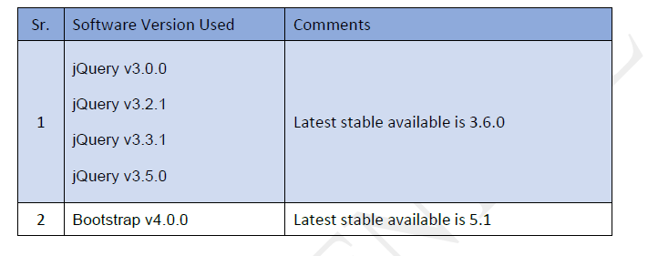

- Usage of Adobe flash technology is highly discouraged. Alternate web capture mechanisms should be evaluated and used.

19. Throughout the project : Inadequate and incorrect business logic should be strengthened using below points.

- While the number of scenarios and field inputs that failed are numerous, only select few are shared as samples in the report. Needs to review all input and output pages and ensure that they are valid and available for the user.

- Functionality test across the application is required to ensure only completed modules are released in production. Data consistency and accuracy should be one of the test scenarios to be conducted across modules.

- Incomplete Functionalities

- Multiple Records Update :

- HTML report as XLS

